SPRINT-3

|  |  |
| --- | --- |
| **TEAM ID** | **PNT2022TMID42671** |
| **Project Name** | **IoT Based Smart Crop Protection System For Agriculture** |
| **Maximum mark** | **20 marks** |

**Description:**

The Cloud Object Storage and Cloudant DB are used to store the data from the device. The MIT app is designed for the user for visual of data at any time from any where and also able to control the motor from the app.

**BUCKET CREATION**

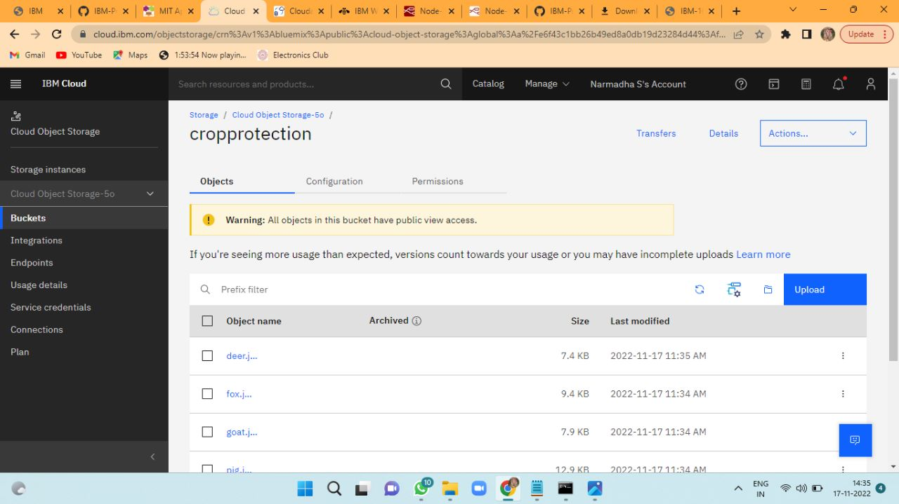

**CLOUDANT -DB**

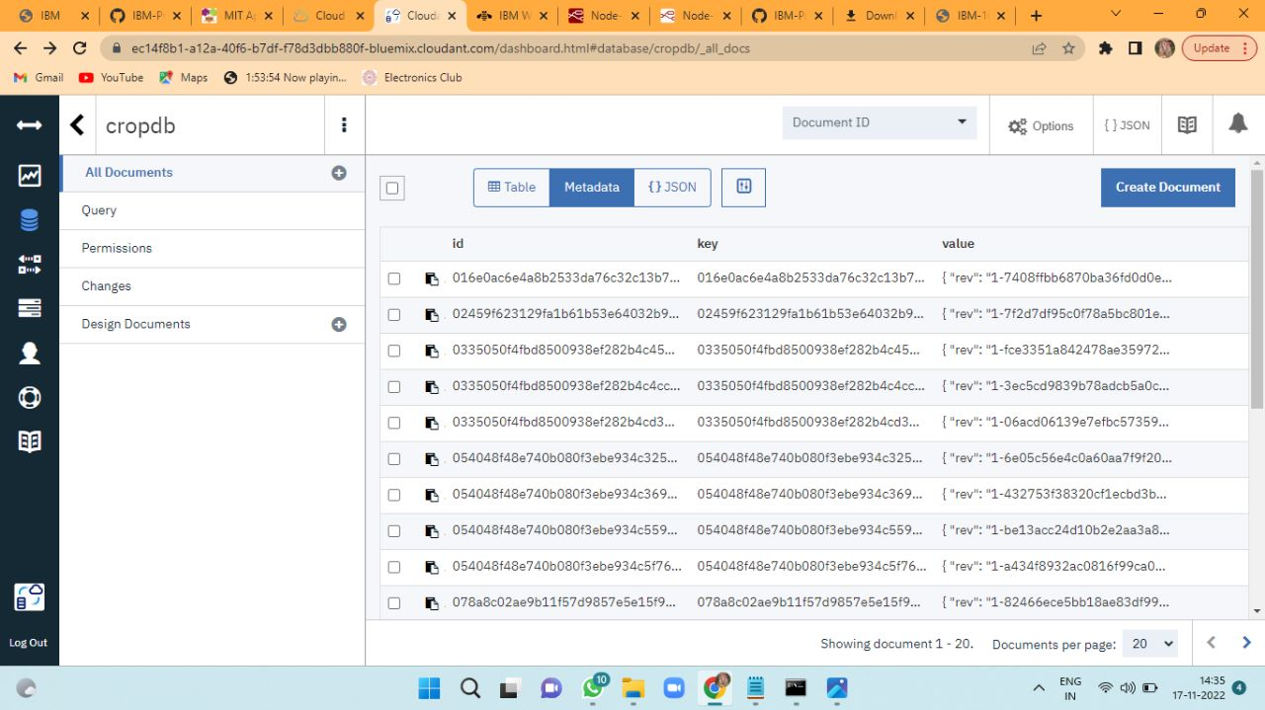

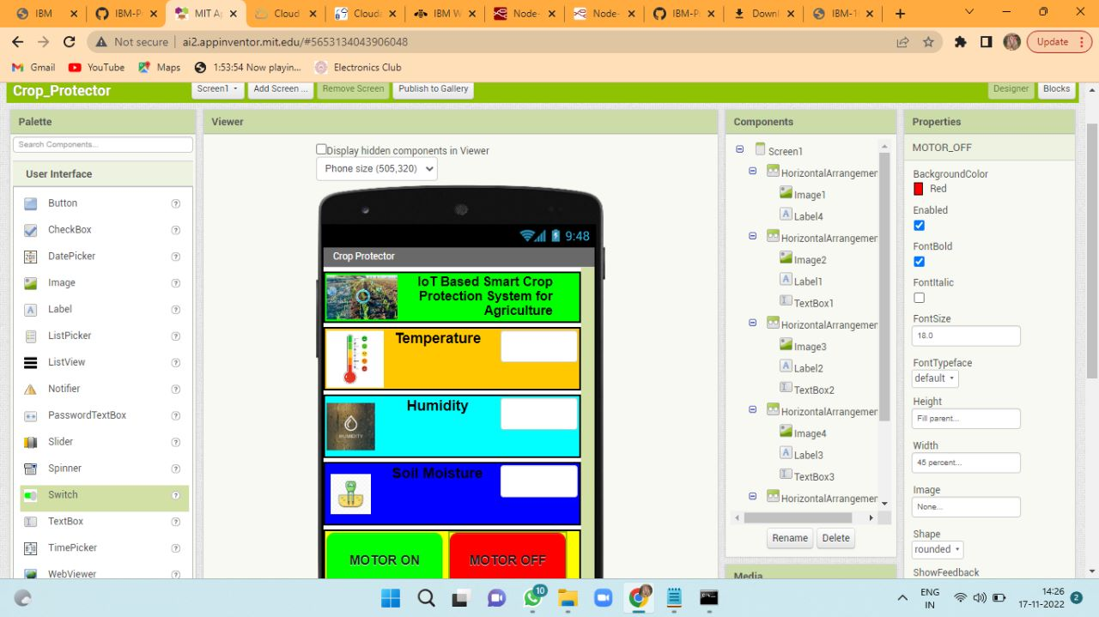**MIT DESIGN CREATION**

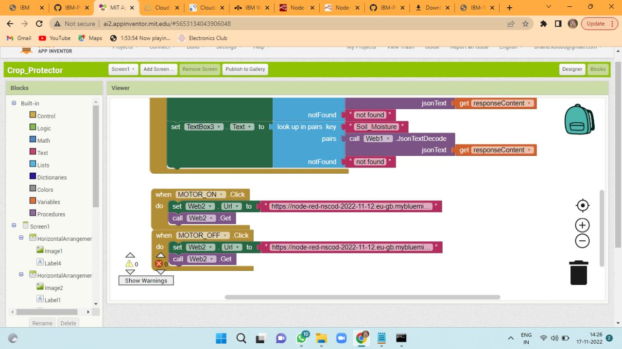**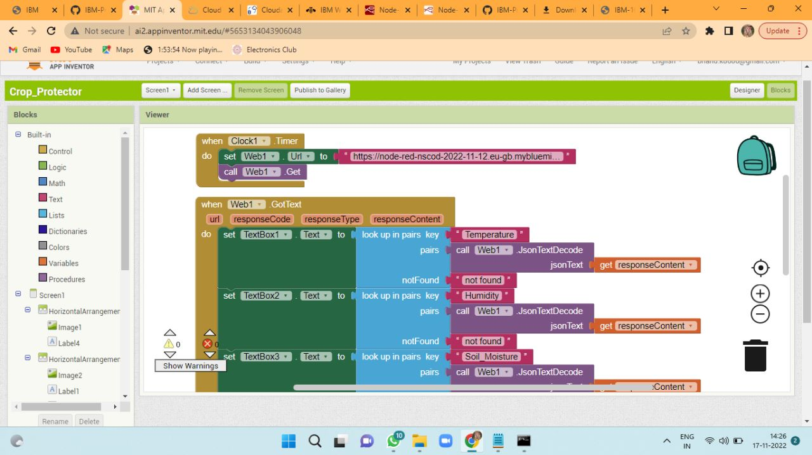MIT BLOCK CREATION**